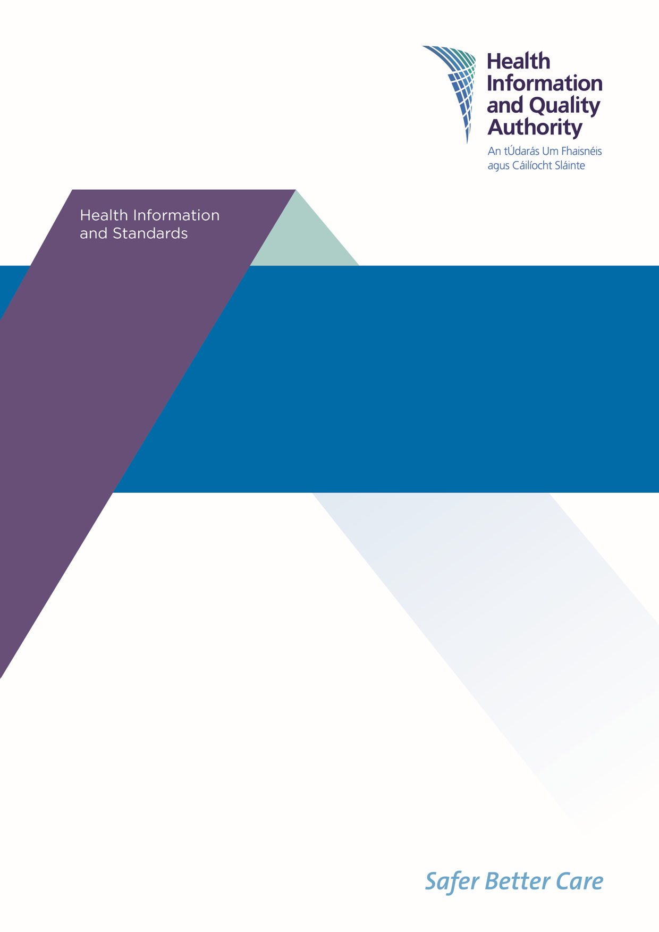

Draft National Standards for Information Management in Health and Social Care

**Public Consultation Feedback Form**

**October 2022**

|  |
| --- |
| The Health Information and Quality Authority (HIQA) is holding a public consultation to give people an opportunity to provide feedback on the Draft National Standards for Information Management in Health and Social Care (referred to in this document as the draft standards).  Your views are very important to us, and we will carefully assess all feedback received and use it to help develop the final standards which will be submitted to the Minister for Health for approval.  **Please note:** the focus for this consultation is the content and structure of the draft standards. The final design and layout of the standards will be developed after the public consultation.  We welcome responses to all questions, and there will be an opportunity at the end of the survey to provide any additional general comments. |

|  |
| --- |
| The feedback from your consultation form will be used to develop the Draft National Standards for Information Management in Health and Social Care, for research purposes and to inform further reports. Any information you provide will be held securely and will not be published, subject to legal requirements under Freedom of Information (FOI) legislation or where you are responding on behalf of an organisation, in which case the name and type of organisation will be published in Summary of Stakeholder Involvement Report.  **The closing date for the public consultation is:**  **5pm, 19th December 2022.** |

**Instructions for submitting feedback**

|  |
| --- |
| * The draft standards document is available at [www.hiqa.ie](http://www.hiqa.ie). * If you are commenting in a personal capacity, there is no need to provide your name or any other personal information. However, if you would like to be contacted to take part in future stakeholder engagement, there is an option to provide your name and contact number. * If you are commenting on behalf of an organisation, please combine all feedback from your organisation into one submission. In this case, we will request a name and contact number for a designated representative from your organisation in case we need to verify the authenticity of your contribution. * When referring to a specific section of the standards document, please include the section and page number that you are commenting on. * Do not paste other tables into the boxes already provided — type directly into the box as the box expands. * Please spell out any abbreviations that you use.   **You can email or post a completed form to us. You can also complete and submit your feedback on** [**www.hiqa.ie**](http://www.hiqa.ie)**.** |

**Data Protection and Freedom of Information**

|  |
| --- |
| * HIQA will only collect personal information during this consultation for the purposes of verifying your feedback or where you have indicated that you would like to be contacted to partake in future stakeholder engagement. If you have any concerns regarding your data, please contact HIQA’s Information Governance and Assurance Manager on [infogovernance@hiqa.ie](mailto:infogovernance@hiqa.ie). * Please note that HIQA are subject to the Freedom of Information (FOI) Act and the statutory Code of Practice in relation to FOI. Following the consultation, we will publish a stakeholder involvement report summarising the responses received, which will include the names and types of organisations that submitted feedback to us. For that reason, it would be helpful if you could explain to us if you regard the information you have provided to us as being confidential or commercially sensitive. * If we receive a request for disclosure of the information under FOI, we will take full account of your explanation, but we cannot give you an assurance that confidentiality can be maintained in all circumstances. |

# About you

## Are you providing feedback as:

**an individual**

*(If you would like to be contacted to participate in future stakeholder engagement, please provide your name and contact number below. Otherwise, please move on to the next question.)*

Click here to enter text.

**on behalf of an organisation**

*(If you are responding on behalf of an organisation, please provide your organisation’s name and contact details below for verification purposes.)*

Click here to enter text.

## Are you commenting:

**In a professional capacity**   
*(Please use the box below to specify your role in the organisation you currently work for.)*

Click here to enter text.

**As a member of the public / user of health and social care services**

*(If you would like to provide any additional details, please share in the box below.)*

Click here to enter text.

# Your feedback on the draft standards

|  |
| --- |
| In this section, we would like to find out what you think of the content of the Draft National Standards for Information Management in Health and Social Care. This section focuses on the three principles, standard statements and features presented in the draft standards. Taken together, the principles, standard statements, and the features provide a common language to describe what good information management practices in health and social care should look like. |

**The draft national standards are underpinned by three principles:**

* A rights-based approach
* Accountability
* Responsiveness.

The questions in this section are not intended in any way to limit your feedback, and other comments relating to the draft national standards are welcome.

|  |
| --- |
| **Please consider the following questions as part of your review of the draft standards:**   1. Do you think all important areas have been covered in each standard statement or are there any areas that should be included or excluded? 2. Are the features listed sufficient to assist staff working in organisations that process health and social care information? |

## Please provide your feedback on the standard statements and features set out under Principle 1: A rights-based approach

Click here to enter text.

## Please provide your feedback on the standard statements and features set out under Principle 2: Accountability

Click here to enter text.

## Please provide your feedback on the standard statements and features set out under Principle 3: Responsiveness

Click here to enter text.

## Are there any other comments or suggestions on the draft standards that you would like to make?

Click here to enter text.

# General Feedback

## Do you think the language used in the draft standards is clear, easy to follow and easy to understand?

**Yes**

**No**

## Do you think the content and structure of the draft standards is clear, easy to follow and easy to understand?

**Yes**

**No**

## Please provide any additional comments on the language, content and structure of the draft standards.

Click here to enter text.

## Having read the draft standards, do you have a better understanding of what good information management looks like for organisations that process health and social care information?

**Yes**

**No**

***Comments:***

Click here to enter text.

## If you work in an organisation that processes health and social care information, having read the draft standards, do you intend to make changes to your work practices?

**Yes**

**No**

**Can you describe what these changes may be?**

*(If this question is not relevant to you, please move on to the next question.)*

Click here to enter text.

## What is needed to support the implementation of these standards in the organisation that you work in?

*(If this question is not relevant to you, please move on to the next question.)*

Click here to enter text.

## Are there any other comments that you would like to make about these draft standards?

Click here to enter text.

*Thank you for taking the time to give us your views on the Draft National Standards for Information Management in Health and Social Care.*

**Please return your form to us by email or post.**

You can **download** a consultation feedback form at [www.hiqa.ie](http://www.hiqa.ie) and then **email** the completed form to: [healthinformation@hiqa.ie](mailto:healthinformation@hiqa.ie)

**or**

Print the consultation feedback from and **post** the completed form to:

Health Information Quality Team,

Health Information and Quality Authority,

Unit 1301,

City Gate,

Mahon,

Cork

T12 Y2XT

You can also complete an **online consultation form** at [www.hiqa.ie](http://www.hiqa.ie)

If you have any questions on this document, you can contact the HIQA Health Information Quality Team by:

**Phone:** 021 240 9300 or **Email:** [healthinformation@hiqa.ie](mailto:healthinformation@hiqa.ie)

Please ensure that you return your form to us by **5pm on 19 December 2022**.